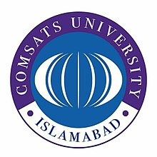
COMSATS University Islamabad
Graduate Office
Department of Management Sciences
Park Road, Tarlai Kalan, Islamabad, Tel: +92-051-90496071

Plagiarism Free Certificate
CUI/MS/Grad/20/ Date: July 31, 2019
It is certified that the thesis of following graduate student was checked for Plagiarism by the respective Supervisor, HoD, Chairman and Dean by using the relevant software.
The results are within the acceptable range, the main result of work is genuine and not taken from any other source.
Sr. | Registration # | Name | Thesis Title
1 | FA14-PMS-022 | ATTAYAH SHAFIQUE | Pleonexia and Crocodile Rules Developed using Performance Measures: Evidence from Pakistan Stock Exchange.

______________
Attayah Shafique
PhD Scholar

______________________
Dr. Usman Ayub
Supervisor

________________
In-charge/Head,
Department of Management Sciences
CUI, Islamabad.

___________________________
Chairperson, (Management Sciences)

____________________________
Dean, Faculty of Business Administration

